Linux Fundamentals

File System Navigation (cd, ls, pwd).

- Cd :- The cd command in Linux stands for change directory and is used to navigate between directories in the file system.
Command : cd
- LS :- The ls command in Linux is a fundamental terminal command used to list files and directories in a specified location, typically the current working directory
- Pwd :- The pwd command in Linux stands for Print Working Directory.

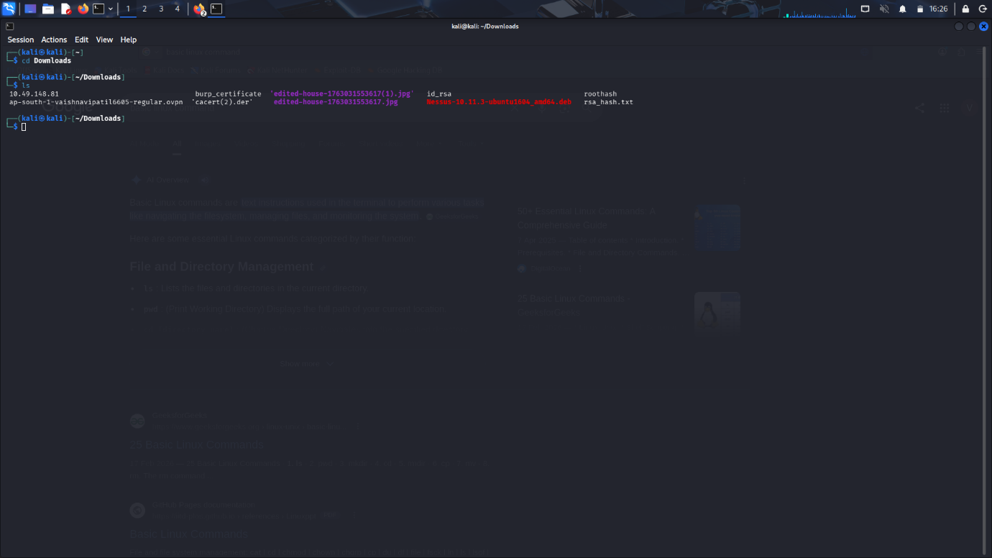
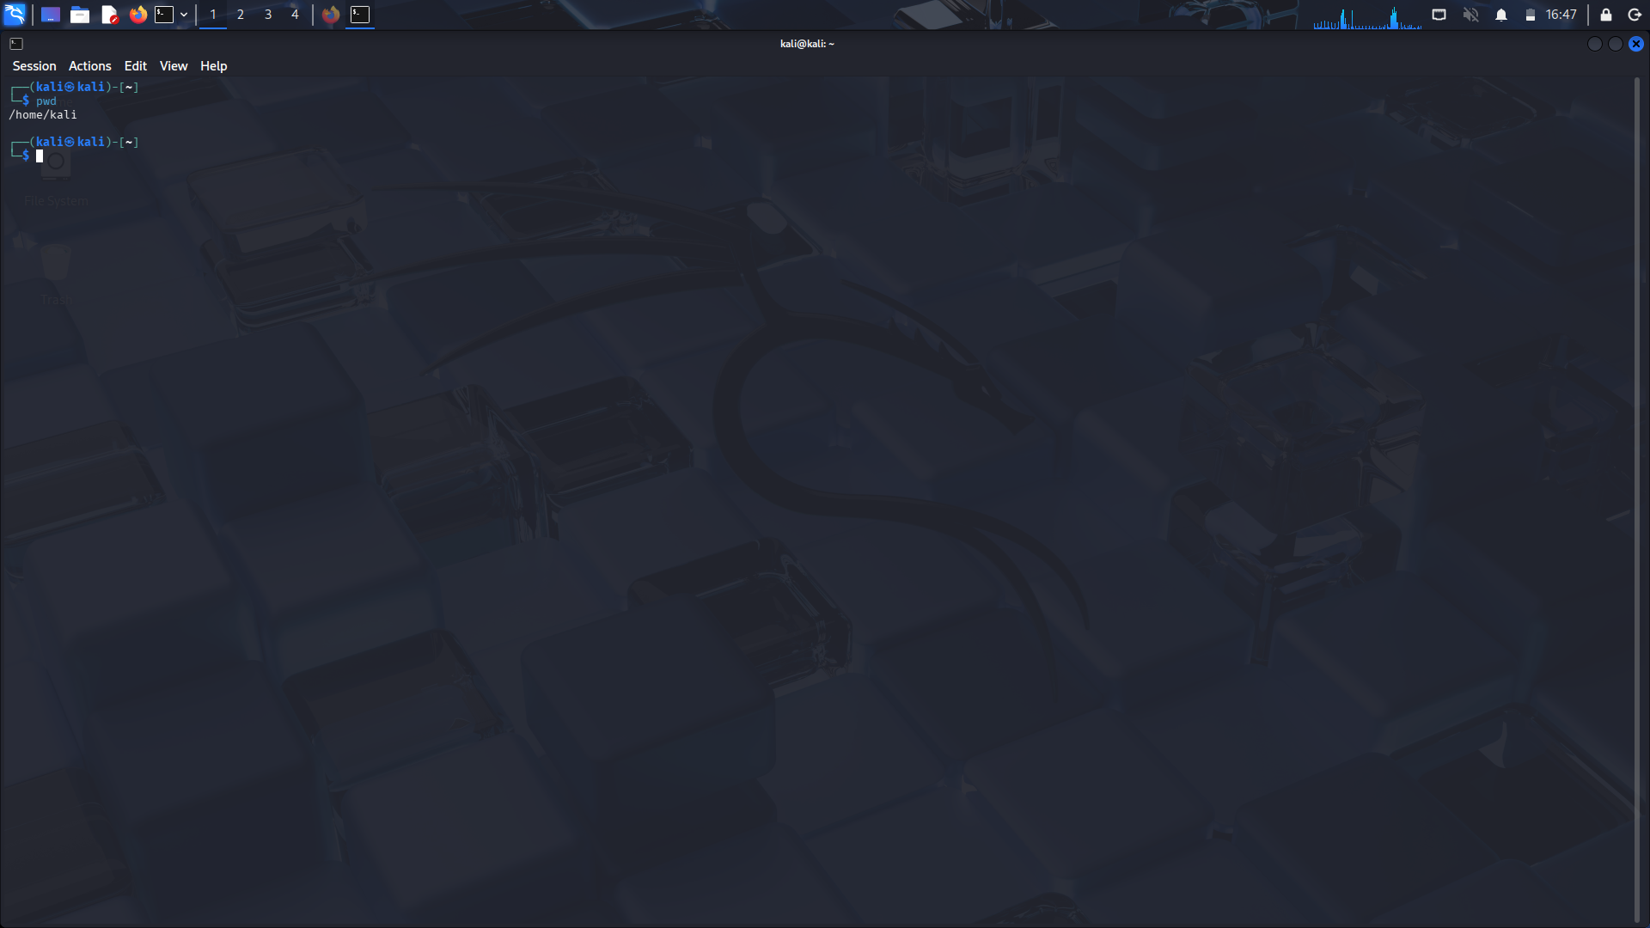

File & Directory Permissions (chmod, chown).

- Chmod :- The chmod command in Linux is used to modify file and directory permissions, controlling who can read, write, or execute a file

- Chown :- The chown command in Linux is a fundamental utility used to change the ownership of files, directories, and symbolic links.

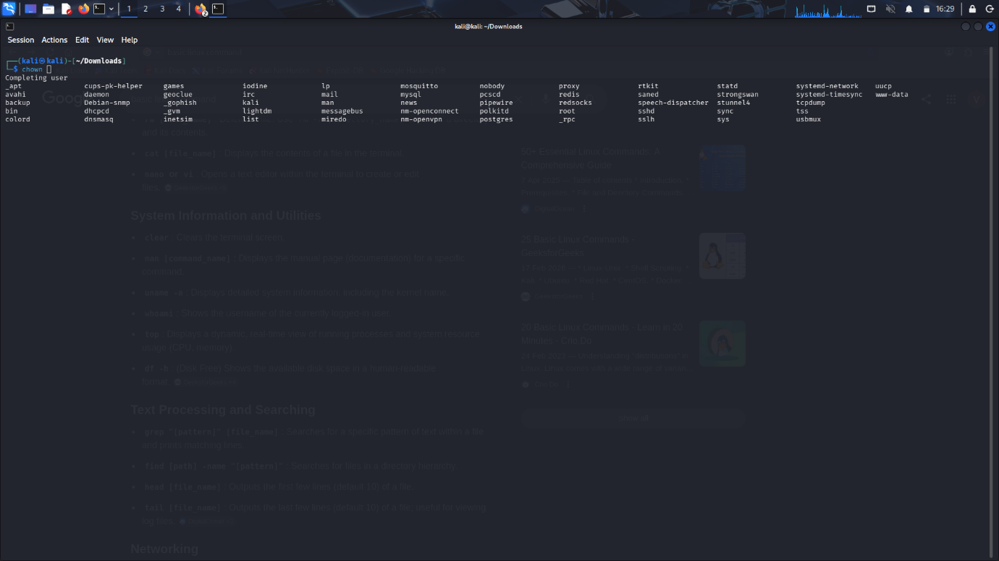

Package Management (apt, dpkg).

- Apt :- apt is a command-line package management tool used in Debian-based Linux distributions such as Ubuntu, Debian, and Linux Mint. It serves as a high-level interface for the Advanced Package Tool (APT) system, simplifying the process of installing, updating, removing, and managing software packages.

- Dpkg :- dpkg is the primary command-line tool for managing Debian packages (.deb) on Debian-based Linux distributions like Ubuntu. It is a low-level package management system used to install, remove, configure, and provide information about software packages directly on the filesystem
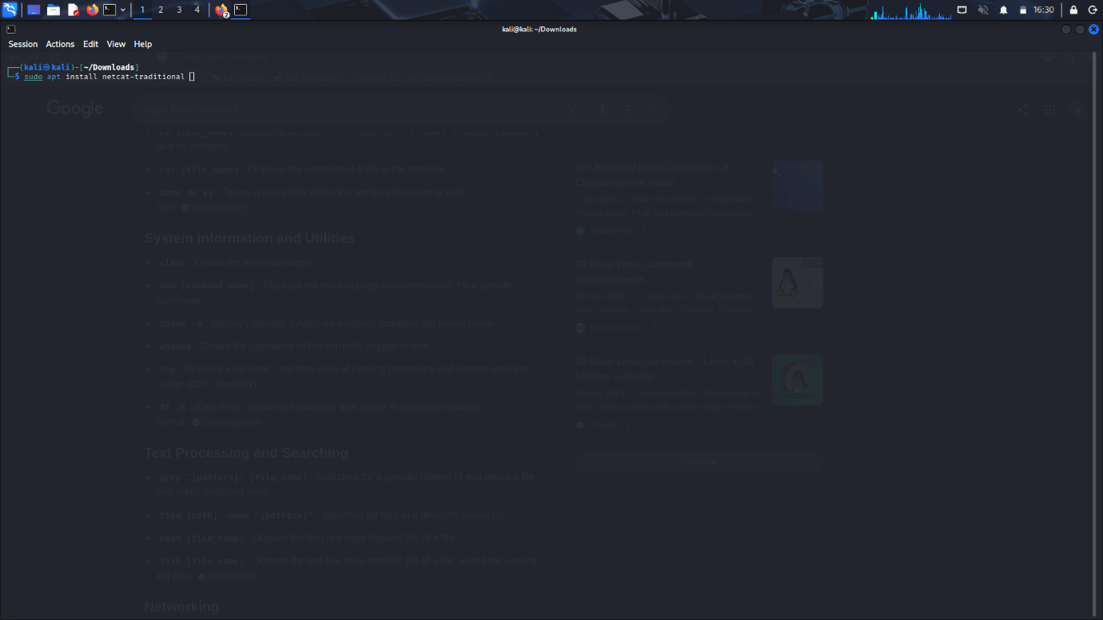

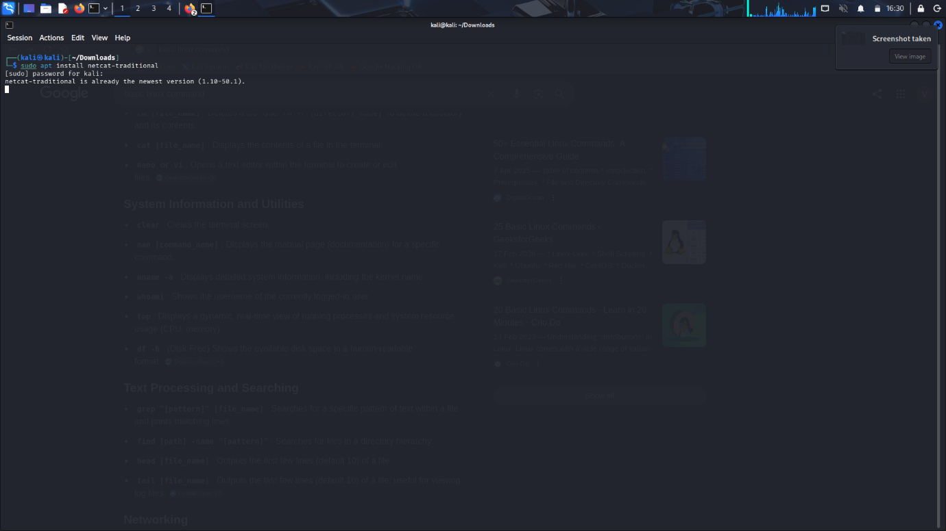

Networking Commands (ifconfig, ping, netstat, traceroute).

- Ifconfig : ifconfig is a Linux networking utility used to view and adjust the configuration of network interfaces. It provides control over interface behavior and displays essential network-related information.

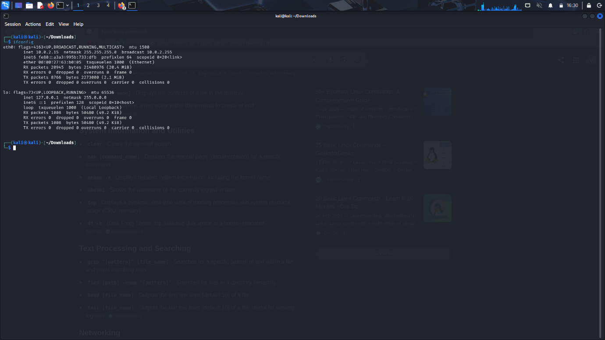

- Ping :- The ping command in Linux is a network utility used to test the reachability of a host on an IP network and measure the round-trip time for messages sent from the originating host to a destination computer
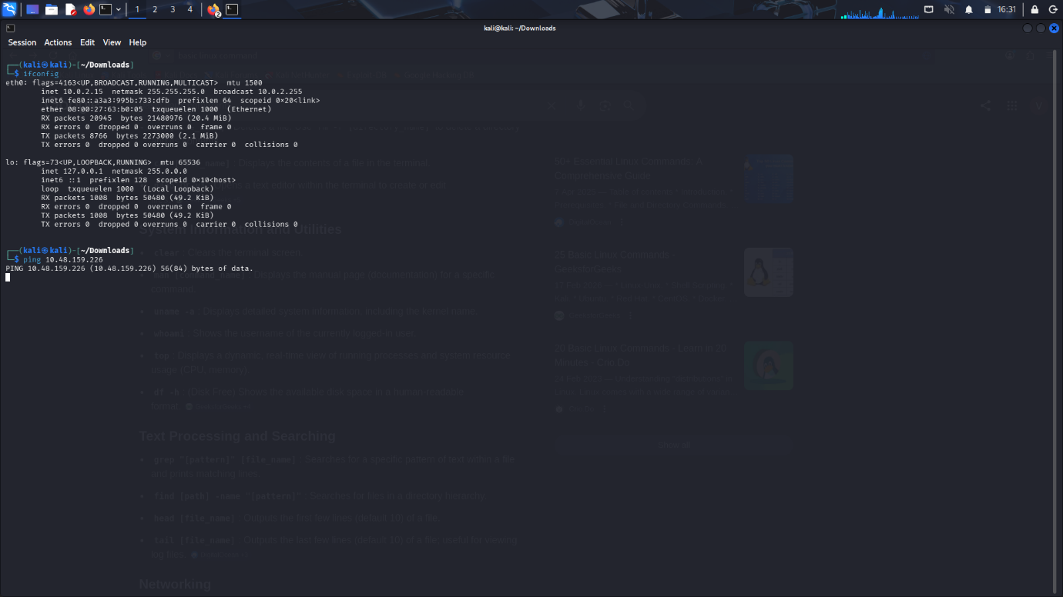

- Netset :- NetSet is not a standard Linux command but rather a third-party Operational Security (OPSEC) utility and automator designed for Kali Linux. It is not part of the core Linux system or standard distribution tools.

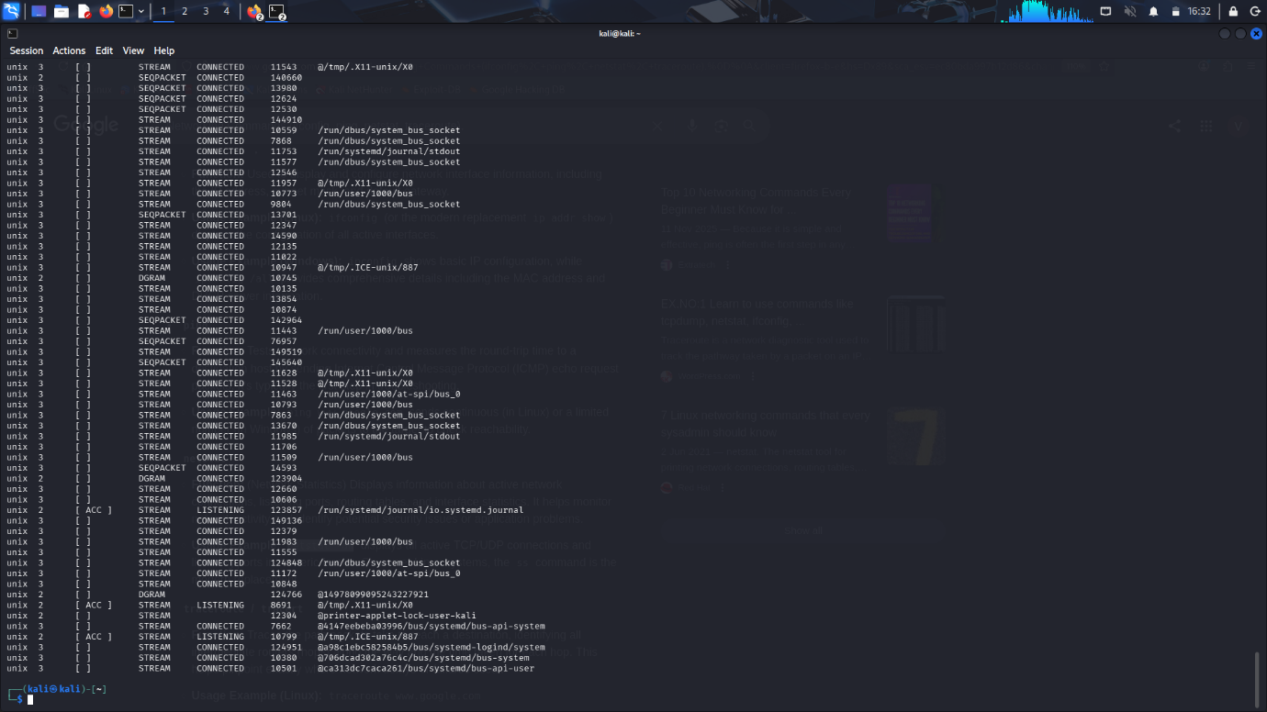

- Traceroute :- Traceroute is a command-line utility in Linux used to trace the path that network packets take from the source to a specified destination host or IP address

